Figure 1: Overview of the automated recruitment workflow
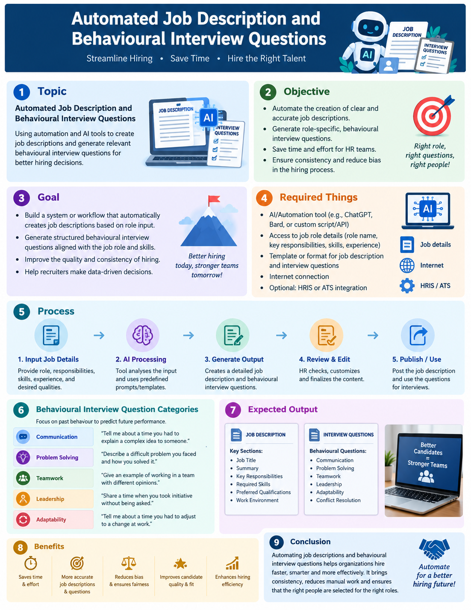

Automated Job Description and Behavioural Interview Questions

1. Topic
Automation of Job Description (JD) creation and generation of behavioural interview questions using AI and workflow automation tools.

2. Objective
The objective is to create a system that automatically prepares clear, structured, and role-specific job descriptions and behavioural interview questions. The system reduces manual effort, improves consistency, and helps recruiters or HR teams prepare interview materials quickly.

3. Goal
• Generate a complete job description from basic job-role information.
• Identify responsibilities, qualifications, skills, and experience requirements.
• Generate behavioural interview questions relevant to the role.
• Save HR/recruiter time and reduce repetitive work.
• Produce a standardized and easy-to-use interview document.

4. Required Things
• Job role/title
• Department or business function
• Job location and work arrangement
• Required education and experience
• Technical and soft skills
• Key responsibilities
• Preferred qualifications
• AI/LLM tool for generating content
• Automation platform such as n8n, Make, or Zapier
• Input form, spreadsheet, or database
• Document generation tool/template
• Output storage such as Google Drive, OneDrive, or local storage

5. Process
Step 1 – Collect Input:
Collect job-role details such as title, department, responsibilities, skills, experience, and qualifications.
Step 2 – Validate Input:
Check that the required job information is available and remove incomplete or inconsistent entries.
Step 3 – Generate Job Description:
Send the role information to an AI model using a structured prompt. Generate the job summary, responsibilities, qualifications, skills, and other relevant sections.
Step 4 – Generate Behavioural Interview Questions:
Create role-specific behavioural questions covering teamwork, communication, problem-solving, leadership, adaptability, conflict handling, accountability, and other relevant competencies.
Step 5 – Review and Format:
Check the generated content for relevance, clarity, duplication, inappropriate requirements, and consistency with the supplied role information. Format the content using a standard template.
Step 6 – Create Document:
Automatically place the approved JD and behavioural interview questions into a Word document or another selected document format.
Step 7 – Store or Share:
Save the document in the selected storage location and optionally send it to the recruiter, HR team, or hiring manager.

6. Behavioural Interview Question Categories
• Teamwork: Describe a time when you worked with a difficult team member. How did you handle the situation?
• Communication: Tell me about a situation where you had to explain a complex idea to someone unfamiliar with the subject.
• Problem-solving: Describe a challenging problem you faced and the steps you took to solve it.
• Adaptability: Tell me about a time when priorities changed suddenly. How did you respond?
• Leadership: Describe a situation where you took responsibility for leading a task or project.
• Conflict management: Tell me about a disagreement at work and how you resolved it.
• Accountability: Describe a mistake you made at work and what you learned from it.
• Time management: Tell me about a time when you had several important tasks with competing deadlines.

7. Expected Output
The automation should produce a professional document containing:
• Job title and job summary
• Job responsibilities
• Required qualifications and experience
• Technical and behavioural skills
• Preferred qualifications
• Role-specific behavioural interview questions
• Optional evaluation criteria or interviewer notes
• Consistent formatting suitable for HR and recruitment use

8. Benefits
• Faster preparation of recruitment documents
• Reduced repetitive HR work
• Consistent job-description structure
• Role-specific interview preparation
• Improved organization and documentation
• Easy integration with recruitment workflows
• Scalable for multiple job roles

9. Conclusion
An automated Job Description and Behavioural Interview Question system can streamline the recruitment preparation process. By combining structured job inputs, AI-generated content, workflow automation, human review, and document generation, HR teams can produce standardized recruitment materials efficiently.

